Reminder of instructions:
- Please read these instructions and then remove this section in blue text before saving, so that your title is at the top of the page.
- The total length is recommended to be 300 words (title, authors, affiliations, and references are not included in this word count). The abstract must fit in the template on one A4 page.
- Include the presentation title, author names, affiliations and references in the abstract submissions Word document as per template.
- Please underline the name of the author who will present the abstract.
- Abstract text should be entered in sentence case (do not type in CAPITAL LETTERS).
- Rename the file to ‘LASTNAME_ AFPS2025’ and save as a Word document to upload. DO NOT save as a PDF file.

Title in Bold, Capitalise the First Letter of Each Word, No Full Stop here
John A Smith¹, Jack N Smith^{1,2}.
Department Name, Organisation¹, City, State, Country;
Department Name, Organisation², City, State, Country.

Background and aims. Do not change the margins, font, size, or any other settings in this template. This format must be used for abstract submissions. The easiest way to do this is to download the template from the conference website and replace the content with your own material.

Methods. Text to begin immediately following the heading without additional line spacing.

Results. You can place figures and tables at the top or bottom of the page, or in the middle of the text on the same page as the relevant text (see Figure 1, Table 1). Captions should be numbered (e.g., “Table 1” or “Figure 2”), centered and placed beneath the figure or table. Please note that the words “Figure” and “Table” should be spelled out.

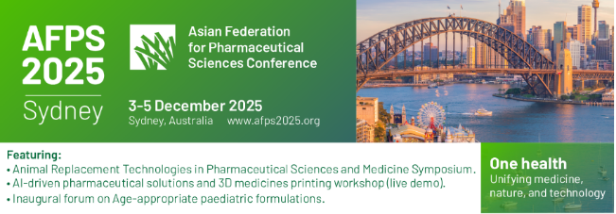
Text | Text | text
Figure | 1 | 2
Figure | 1 | 2

Figure 1. For images, be sure to have a good resolution image. Table 1. Table captions should be placed below the table.

Conclusion/Discussion. It is important that you write for the AFPS 2025 conference audience. This year’s themes include animal replacement technologies, AI-driven pharmaceutical solutions, 3D medicines printing, and age-appropriate paediatric formulations. We wish you good luck with your abstract and look forward to welcoming you in Sydney

References: After the discussion, you may include Acknowledgements section, for example, to thank funding sources or supporters of your work.
(1) Yoo, O. (2025) JAC 56:23-33
(2) Phan, T. et al (2025) Pharmacology, ed Ono Y. pp 12-23, Tokyo, Abbey Road Press

